MORRIS TOWNSHIP POLICE DEPARTMENT
49 WOODLAND AVENUE
MORRISTOWN, NEW JERSEY 07960
WWW.MORRISTWP.COM
973.326.7470

EMPLOYMENT OPPORTUNITY

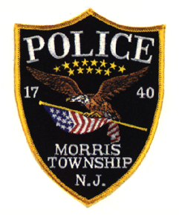
The MORRIS TOWNSHIP POLICE DEPARTMENT located in Morris County is currently accepting resumes for the position of Police Officer. Applicants at the time of appointment must possess, a valid New Jersey Driver’s License and meet all qualifications of N.J.S.A. 40A:14-118 et. seq.

Education requirements: Shall possess a minimum of sixty (60) credits from an accredited college or university. In lieu of the minimum of sixty (60) college credit requirement, an applicant: shall have completed four (4) years of active military service with an honorable discharge and be a high school graduate or equivalent.

Interested applicants may mail, email or drop off the Resume to:

MORRIS TOWNSHIP POLICE DEPARTMENT
49 Woodland Avenue
Morristown, New Jersey 07960
Attn: Chief Mark DiCarlo
Email option: koshea@mtpd1422.com

All resumes will be reviewed and all interested individuals will be notified via email as to their progress in the Selection Process.

Resumes must be received by 3:00 PM, Tuesday, February 1, 2022.

The Township of Morris is an Equal Opportunity Employer (EOE).

JANUARY 2022

“The residents of Morris Township are best served when the diversity of the Police Department mirrors that of our community”
Chief Mark DiCarlo

