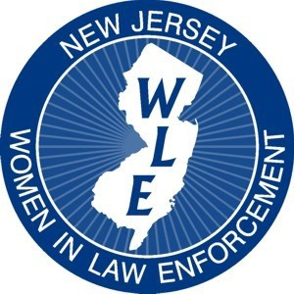
New Jersey Women in Law Enforcement Presents:

16th Annual Leadership Training

Conference and Awards Ceremony
Co-Sponsored by Monmouth University
Department of Criminal Justice, Graduate Department

Embracing the Warrior Mindset: Personal Stories of Resilience

May 21, 2020 8:15 AM—4:00 PM
(Registration with continental breakfast begins at 8:15 a.m. and presentations will begin promptly at 9:00 a.m.)

SPEAKERS
Connor Manion – Police Officer from Morristown Police Department and a member of the Garden State Equality LGBTQ+ Liaison Team
Clark Fredericks – Author & Motivational Speaker “From the Darkness There is Light, No More Secrets” – A presentation on childhood sexual abuse, drug addiction, and murder
Heather Glogolich – Lieutenant Morris Township Police Department - “You Are Enough” – An Intimate Look at Domestic Violence from the LEO Perspective
Roy Diaz – Retired Police Officer who works for Cop-2-Cop sharing a personal experience with the stresses of law enforcement and how to cope
TO BE HELD AT:
Monmouth University, Rebecca Stafford Student Center, Anacon Hall-2nd Floor
400 Cedar Avenue, West Long Branch, NJ 07764
https://www.monmouth.edu/map/

$75.00 Registration Only or $125.00 for Registration and a One Year Membership
(includes full day of training, continental breakfast and lunch)
Name: Rank:

Agency:

Years of Service:

Address:

E-Mail: Phone Number:

Are you a NJWLE Member? YES or NO
Is this your first NJWLE conference? YES or NO
Has your rank changed since last NJWLE conference? YES or NO
Have you ever received an award from NJWLE? YES or NO
Are you interested in being a part of the board? YES or NO
Please circle option for billing purposes:

Option 1: Conference Only ~ $75

Option 2: Conference and 1 Year NJWLE Membership ~ $125

PURCHASE ORDER (Point of Contact : )

PAYMENT AT DOOR
You may scan registration form and pay through PayPal or
Make checks payable to: NJWLE
New Jersey Women in Law Enforcement
3817 Crosswicks Hamilton Square Road
Suite 157 Hamilton, NJ 08691
(Purchase Orders/Invoices accepted: email them to NJWLE@yahoo.com)
For further information or to register online, please visit our website at: www.NJWLE.org
Or contact Detective Sergeant Danielle Oliveira, at NJWLE@yahoo.com
NJWLE is a 501(C)6 Non-Profit Organization

