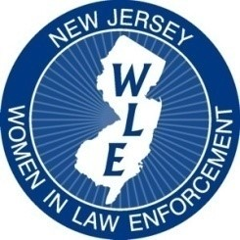
NEW JERSEY WOMEN IN LAW ENFORCEMENT

2022 Training Conference
Grand Marquis
Old Bridge, New Jersey
SPONSORSHIP REGISTRATION FORM
The NJWLE Training Conference’s goal is to unite federal, state, county and municipal law enforcement officers in a dynamic setting to discuss and learn about relevant information as it relates to the law enforcement community.

Your sponsorship will help to support the mission of the conference through the various events, presenters, keynote speaker, training sessions and awards ceremony. NJWLE is a registered 501(c) 6 non-profit organization. We support no political affiliations. Tax ID: 20-3932315
PLEASE PRINT
Name/Organization___________________________________________________________
Address__________________________City____________________State____________
Zip_______Phone____________________Cell__________________Email______________
All sponsors will be recognized in our Conference Program and announced at our Awards Ceremony.
PLEASE INDICATE LEVEL OF SPONSORSHIP:
AMOUNT $__________________
Platinum Sponsor: $1,000 and up: Signage displayed on PowerPoint at conference, PLUS 2 Free tickets to the conference PLUS additional large signage displayed at the conference
Gold Sponsor: $500 - $1,000: Signage displayed on PowerPoint at conference PLUS 1 Free ticket to the conference
Silver Sponsor: $0-500: Signage displayed on PowerPoint at the conference

Make checks payable to: NJWLE Training Conference
Mail payment to: NJWLE
3817 Crosswicks Hamilton Square Road, Suite 157
Hamilton, New Jersey 08691

